Christopher Horyczun
September 29, 2025
CS1450
Assignment 4 Design Notebook
Problem Solving: To learn how to work with arrays that are not completely full and learn more about Array List manipulation. We will be creating a program that models the ocean. Using grids & elements, where elements are either land or ships. Once the land and ships are reported on the ocean, we will display the grid and print a ship report (smallest capacity to largest capacity).
Understanding:
What I do know | What I don’t Know
- How to read a file  - How to make a report  - How to make classes | - How to make a 2D array  - How to make the grid and element overlap  - How to display as requested

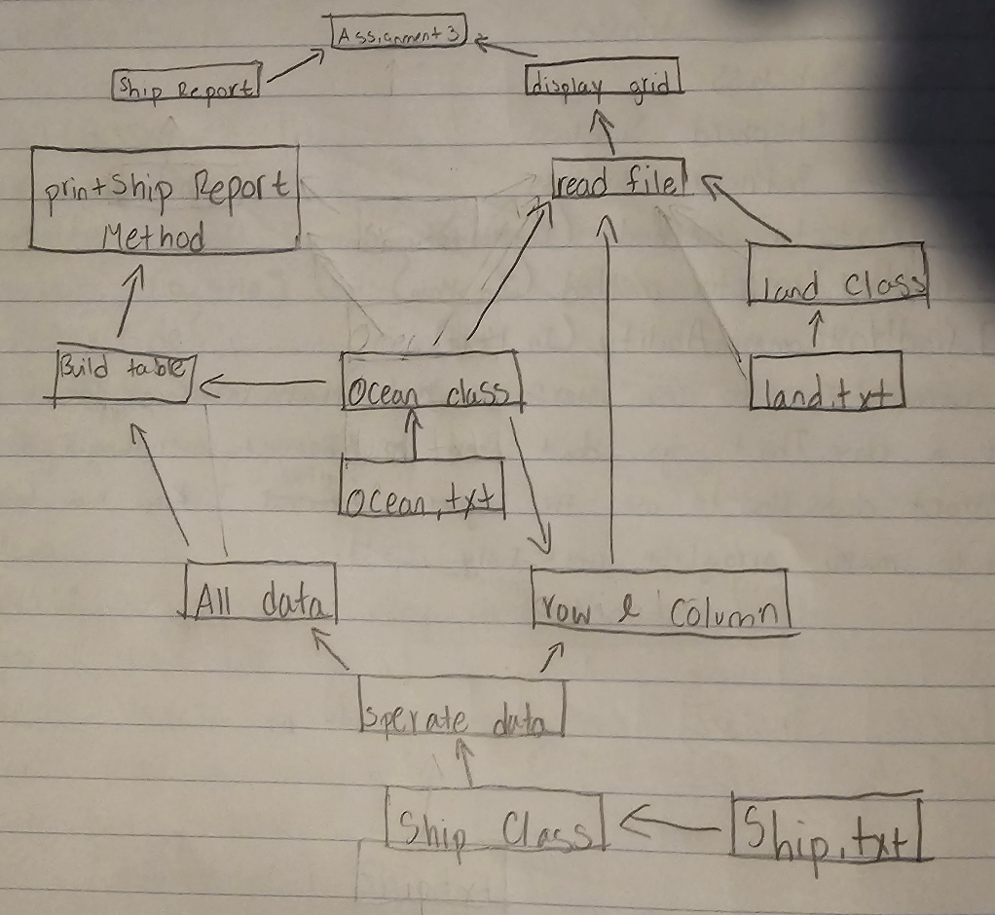
Design Sketch:

Pseudocode:
Main
Open Ocean file
Read ocean name, number of rows, number of columns
Create objects for those
Close ocean
Open land file
While land
Read rows and columns
Create land objects
Add land to ocean by rows and columns
Close land file
Open ship file
While ships
Read rows and columns, cap, class, name
Create ship objects
Add ships to oceans using rows and columns
Close ship file
Display the ocean
Call ship report

PrintShipReport
Create an array
For each row
For each column
Get element using rows and columns
If element is a ships
Add ship to array
Sort array of ships by capacity
For each ship in array
Print ship details
//end
Lesson Learned: I learned how to make a 2d array and to read multiple files at once. I increased my knowledge on printf. Got a better understanding of ArrayList and how they function, as well as compare to.

